Lab 14 – Project-Creating Currency Converter in LABVIEW

Project-Creating Currency Converter in LABVIEW.

1. PKR to IR

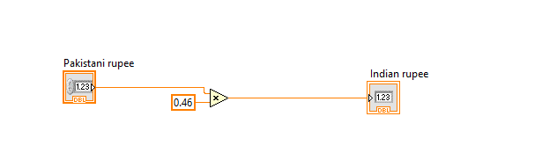OUTPUT:

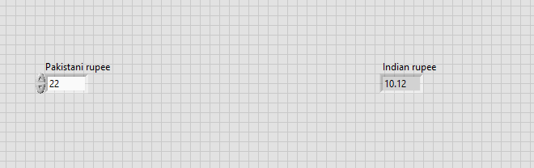

1. PKR to USD

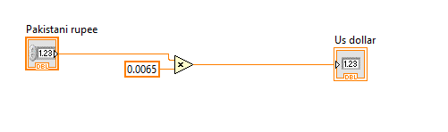

OUTPUT:

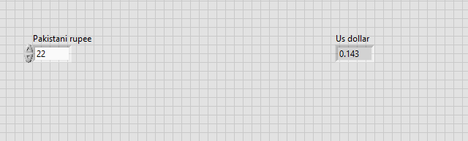

1. PKR to Chinese Yuan

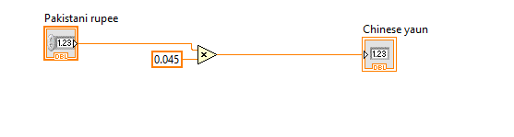

OUTPUT:

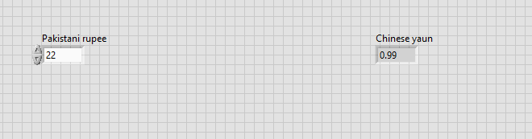

1. PKR to Saudi Riyal

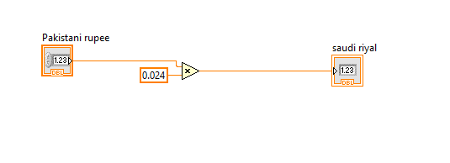

OUTPUT:

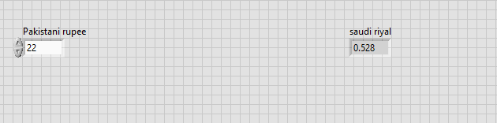

1. PKR to Iraqi Dinar

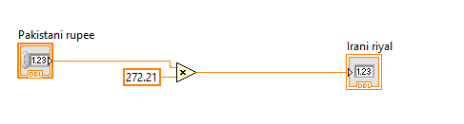

OUTPUT:

